**HOTEL RESERVATION SYSTEM**

**A MINI PROJECT REPORT**

**SUBMITTED BY**

**MARCELLUS JESUDASAN 231501096**

**G MEENAKSHI 231501097**

**MEGHNA RAJESH 231501098**

In partial fulfillment for the award of the degree of

BACHELOR OF ENGINEERING IN

COMPUTER SCIENCE AND ENGINEERING

RAJALAKSHMI ENGINEERING COLLEGE (AUTONOMOUS) THANDALAM

CHENNAI-602105

2024 - 2025

**BONAFIDE CERTIFICATE**

Certified that this project report “**HOTEL MANAGEMENT SYSTEM**” is the bonafide work of **“MARCELLUS JESUDASAN (231501096), G MEENAKSHI (231501097), MEGHNA RAJESH (231501098)”** who carried out the project work under my supervision.

**Submitted for the Practical Examination held on**

**SIGNATURE**

**Mr. U. Kumaran,**

**Assistant Professor (SS)**

**AIML,**

**Rajalakshmi Engineering College,   
 (Autonomous),**

**Thandalam, Chennai - 602 105**

**INTERNAL EXAMINER EXTERNAL EXAMINER**

**ABSTRACT**

The **Hotel Reservation System (HRS)** using **Database Management System (DBMS)** is a robust, efficient, and scalable application designed to automate and manage hotel bookings, reservations, and guest services. This system utilizes a relational database (such as MySQL or PostgreSQL) to store and manage essential data, including room availability, guest profiles, booking details, payments, and hotel services.

Guests can search for available rooms based on their preferences (dates, room type, and amenities), make reservations, and securely process payments via integrated payment gateways. The system ensures real-time updates on room availability, preventing overbookings. Admin users have access to a centralized dashboard where they can manage room inventories, view and modify reservations, check-in/check-out guests, and generate financial reports.

The DBMS ensures data consistency, integrity, and security by supporting features like transactional processing, multi-user access control, and backup mechanisms. Additionally, it allows for efficient querying, reporting, and data retrieval, enabling the hotel staff to make informed decisions and improve operational efficiency. The system also facilitates easy modifications and scalability, allowing the database to grow as the hotel expands.

Overall, the **Hotel Reservation System with DBMS** enhances the guest experience by providing a smooth, intuitive reservation process while optimizing hotel operations and increasing occupancy rates. It is ideal for hotels of all sizes and ensures reliable, real-time data management and seamless integration between users and hotel staff.

**TABLE OF CONTENTS**

1. INTRODUCTION

1.1 INTRODUCTION…………………………………………………….…… 1

1.2 OBJECTIVES……………………………………………………………... 1

1.3 MODULES………………………………………………………….……... 2

2. SURVEY OF TECHNOLOGIES

2.1 SOFTWARE DESCRIPTION……………………………………………… 4

2.2 LANGUAGES………………………………………………….…………... 4

2.2.1 MySQL…………………………………………………...……… 4

2.2.2 PYTHON……………………………………………….………... 5

2.2.3 HTML………………………………………………...…………. 5

2.2.4 CSS…………………………………………………...…………. 6

2.2.5 JAVASCRIPT………………………………………...…………. 6

3. REQUIREMENTS AND ANALYSIS

3.1 REQUIREMENT SPECIFICATION……………………………………… 8

3.2 HARDWARE AND SOFTWARE REQUIREMENTS…….……………... 8

3.3 ARCHITECTURE DIAGRAM…………………………………………… 9

3.4 DATA DICTIONARY……………………………………………………… 10

3.5 ER DIAGRAM……………………………………………………………... 13

4. PROGRAM CODE………………………………………………………………...... 14

5. RESULT AND DISCUSSION…………………………………………………….... 39

5.1 RESULT…………………………………………………………………… 39

5.2 TESTING…………………………………………………………………... 39

5.3 FUTURE SCOPE…………………………………………………………… 40

5.4 FRONT-END LAYOUT…………………………………………………… 43

6. CONCLUSION……………………………………………………………………… 46

7. REFERENCES…………………………………………………………………….... 48

**I. INTRODUCTION**

**1.1 INTRODUCTION**

A Hotel Reservation System is a web-based application designed to manage and streamline the process of booking rooms at a hotel. This system enables users to easily search for available rooms, make reservations, and manage their bookings online. The backend of the system relies on a Database Management System (DBMS) for data storage, retrieval, and management, while the front-end interface is built using HTML and CSS to provide a user-friendly experience.

**System Overview**

The core function of the Hotel Reservation System is to allow customers to book rooms by providing necessary details such as check-in and check-out dates, room preferences, and personal information. Hotel staff or administrators can manage room availability, view current reservations, and adjust as needed.

The system's backend is powered by a DBMS (such as MySQL, PostgreSQL, or SQLite) to store and manage the following data:

* Customer Information: Includes user details, payment data, and booking history.
* Room Details: Information about room types, availability, rates, and special services offered.

By combining a powerful database backend with a clean, intuitive front-end, this system not only improves user experience but also increases operational efficiency for the hotel.

* 1. **OBJECTIVES**

1. **Efficient Room Booking**:  
   To create an easy-to-use platform that allows customers to search for available rooms based on their preferences (such as room type, dates, and price) and make secure bookings.
2. **Real-Time Availability Management**:  
   To maintain an up-to-date record of room availability and reservations in real-time, ensuring there is no double booking or conflicts.
3. **User-Friendly Interface**:  
   To design a simple, intuitive front-end using HTML and CSS that allows users to easily navigate the system, search for rooms, and complete the booking process.
4. **Data Management and Security**:  
   To ensure secure storage and retrieval of customer, reservation, and room data using a robust DBMS, with encryption for sensitive information (e.g., passwords and payment details).
5. **Admin Panel for Hotel Management**:  
   To provide hotel staff with a dedicated admin panel for managing reservations, updating room availability, processing customer requests, and viewing booking history.
6. **Scalable and Extensible Design**:  
   To build the system in a way that can be easily scaled to accommodate additional features such as multi-hotel support, seasonal pricing, or user feedback and reviews.

**1.3 MODULES**

### 1. **Guest Module**

* **Registration & Profile**: Create and manage guest profiles.
* **Booking**: Search for rooms, make bookings, and receive confirmations.
* **Payment Integration**: Secure payment processing.
* **Reviews & Feedback**: Rate services after stay.
* **Modifications & Cancellations**: Manage bookings.

### 2. **Admin Module**

* **Room Management**: Manage room types, availability, and pricing.
* **Booking Management**: View and modify guest bookings.
* **Reports**: Generate occupancy, revenue, and guest reports.

### 3. **Room Management**

* **Room Assignment**: Assign rooms based on guest preferences.
* **Inventory & Maintenance**: Track room status (clean, under maintenance)

### **4. Database Module**

### **Users Table**: Guest and admin profiles.

### **Rooms Table**: Room details and availability.

### **Bookings Table**: Guest booking records.

### **Payments Table**: Payment transaction logs.

### **Reviews Table**: Guest ratings and feedback.

### **Reports Table**: Admin-generated report data.

### 5. **Payment & Billing**

* **Payment Processing**: Handle online payments securely.
* **Invoice Generation**: Generate itemized invoices.
* **Tax & Fee Management**: Apply taxes and fees correctly.

**II. SURVEY OF TECHNOLOGIES**

**2.1 SOFTWARE DESCRIPTION**

**VSCODE**

Visual Studio Code (VSCode) is a free, open-source, and lightweight code editor developed by Microsoft. It is widely used by developers for writing, editing, and debugging code. VSCode supports a wide variety of programming languages and provides a rich set of features aimed at increasing productivity.

### **Supported Languages**:

### JavaScript, TypeScript, Python, C++, Java, PHP, HTML, CSS, and many more through extensions.

### **Use Cases**:

* **Web Development**: HTML, CSS, JavaScript, React, Angular, etc.
* **Backend Development**: Node.js, Python, Ruby, and others.
* **Mobile Development**: Flutter, React Native, etc.
* **Data Science**: Jupyter Notebooks, Python libraries (e.g., Pandas, Matplotlib).
* **DevOps**: Scripting, configuration management (YAML, Dockerfiles)

**FLASK**

Flask is a Python-based web framework used to create web applications. It is considered lightweight and flexible because it provides essential tools to build applications without enforcing a specific project structure. At its core, Flask handles HTTP requests and responses, enabling you to create endpoints for specific URLs and define the logic for each. Flask applications run on a web server and can serve dynamic content, interact with databases, and more.

.

**2.2 LANGUAGES**

**2.2.1 MySQL**

MySQL is an open-source relational database management system (RDBMS) that utilizes Structured Query Language (SQL) for managing and manipulating data stored in tables. It is widely used for web applications, software development, and data storage due to its high performance, scalability, and ease of use. MySQL is ACID-compliant, ensuring data integrity and supporting transactions with properties like atomicity, consistency, isolation, and durability. It is cross-platform, meaning it runs on various operating systems like Windows, Linux, and macOS. The system supports complex queries, indexing, and relationships between tables through keys (primary and foreign). With built-in replication, clustering, and backup tools, MySQL ensures high availability and fault tolerance, making it suitable for both small-scale applications and large enterprise systems. It also offers strong security features, including SSL encryption and user authentication, as well as extensibility through stored procedures, triggers, and custom functions. MySQL is commonly used in web development, content management systems (like WordPress), e-commerce platforms, and business applications, making it one of the most popular and reliable database management systems in the world.

**2.2.2 PYTHON**

Python is a high-level, interpreted programming language known for its simplicity, readability, and versatility. Developed by Guido van Rossum and first released in 1991, Python prioritizes ease of use and code readability, making it an excellent choice for beginners, while still powerful enough for professionals working on complex applications. Python supports multiple programming paradigms, including procedural, object-oriented, and functional programming, allowing developers to use the language in various ways depending on their needs. One of Python’s standout features is its clean, easy-to-understand syntax, which reduces the time needed for development and maintenance. Python is dynamically typed and garbage-collected, meaning variables do not need explicit type definitions, and memory management is handled automatically. Python has a large standard library, which includes modules for working with data, file systems, networking, web services, and much more. This extensive library and the ability to install third-party packages via **pip** (Python's package manager) make Python suitable for a wide range of applications, including web development, data analysis, artificial intelligence, scientific computing, automation, and more.

**2.2.3 HTML**

HTML (HyperText Markup Language) is the standard markup language used to create and structure content on the web. It forms the backbone of every webpage by defining its structure, elements, and the relationships between them. HTML uses a system of tags, typically enclosed in angle brackets (e.g., <tag>), to organize and format content. These tags tell web browsers how to display text, images, links, forms, videos, and other elements on a webpage. The language is based on a set of core tags and elements such as headings (<h1>, <h2>, etc.), paragraphs (<p>), lists (<ul>, <ol>), links (<a>), and images (<img>), among others. HTML also allows for embedding media like audio (<audio>) and video (<video>) directly into the page. It provides the structure and semantics for a webpage but doesn’t handle its visual appearance or interactivity—that's where CSS (Cascading Style Sheets) and JavaScript come into play. HTML5, the latest version of HTML, introduced several new features and elements, including semantic tags like <header>, <footer>, <section>, and <article>, which make it easier to define the structure of a webpage in a more meaningful way. These semantic elements improve accessibility, search engine optimization (SEO), and readability of the code. HTML5 also brought support for modern features like offline web applications,

**2.2.4 CSS**

CSS (Cascading Style Sheets) is a stylesheet language used to describe the presentation and layout of a web page written in HTML or XML. While HTML defines the structure and content of the page, CSS controls how that content appears, including elements like fonts, colours, spacing, positioning, and overall layout. CSS helps separate the content from its visual design, allowing web developers to modify the appearance of web pages without changing the underlying HTML structure. CSS can be applied in several ways: inline (directly within HTML elements using the style attribute), internally (within a <style> tag in the HTML document’s <head> section), or externally (linked via a separate .css file, which is the most common method for larger websites). The "cascading" aspect of CSS allows for multiple styles to be applied in a hierarchy, with more specific rules overriding general ones. One of CSS's strengths is its ability to create complex, responsive layouts. Tools like Flexbox and Grid enable developers to design flexible and dynamic layouts that adjust smoothly to different screen sizes, improving the user experience on mobile devices and desktops alike. Additionally, CSS allows for advanced effects like transitions, animations, and pseudo-classes (e.g.,: hover, :focus) to create interactive and engaging interfaces.

**2.2.5 JavaScript**

JavaScript is a dynamic, high-level programming language used to add interactivity and responsiveness to websites. Running on the client side, it enables actions directly within the user's browser, such as animations, form validation, and real-time content updates, without needing to reload the page. As one of the core web technologies alongside HTML and CSS, JavaScript can manipulate the Document Object Model (DOM) to change the structure and style of web pages based on user interactions, making sites more engaging. It also handles events like clicks, hovers, and keypresses, enhancing interactivity. Additionally, JavaScript supports asynchronous programming, which allows it to fetch data from servers in the background through features like Promises and async/await, creating smooth, uninterrupted user experiences. Widely supported by modern browsers, JavaScript is essential for building dynamic, user-driven web applications.

**III. REQUIREMENTS AND ANALYSIS**

**3.1 REQUIREMENT SPECIFICATION**

**User Requirements**

A Hotel Reservation System (HRS) is designed to streamline and automate the process of booking and managing rooms, reservations, and guest services for both hotel guests and the hotel management team. This system typically includes two main user groups: guests and admin/hotel staff. Each group has specific needs and features that the system must address to ensure an efficient, smooth, and seamless experience.

**System Requirements**

There should be a database backup of the Hotel Reservation System. The operating system should be Windows 10 or a higher version of Windows.

**3.2 HARDWARE AND SOFTWARE REQUIREMENTS**

**Software Requirements**

● Operating System: Windows 10

● Front End: HTML, CSS, JavaScript

● Back End: Python, MySQL

**Hardware Requirements**

● Desktop PC or Laptop

● Printer (optional)

● Operating System: Windows 10

● Intel® Core™ i3-6006U CPU @ 2.00GHz or higher

● 4.00 GB RAM or higher

● 64-bit operating system, x64 based processor

● Monitor Resolution: 1024 x 768 or higher

● Keyboard and Mouse

**3.3 HOTEL RESERVATION SYSTEM ARCHITECTURE**

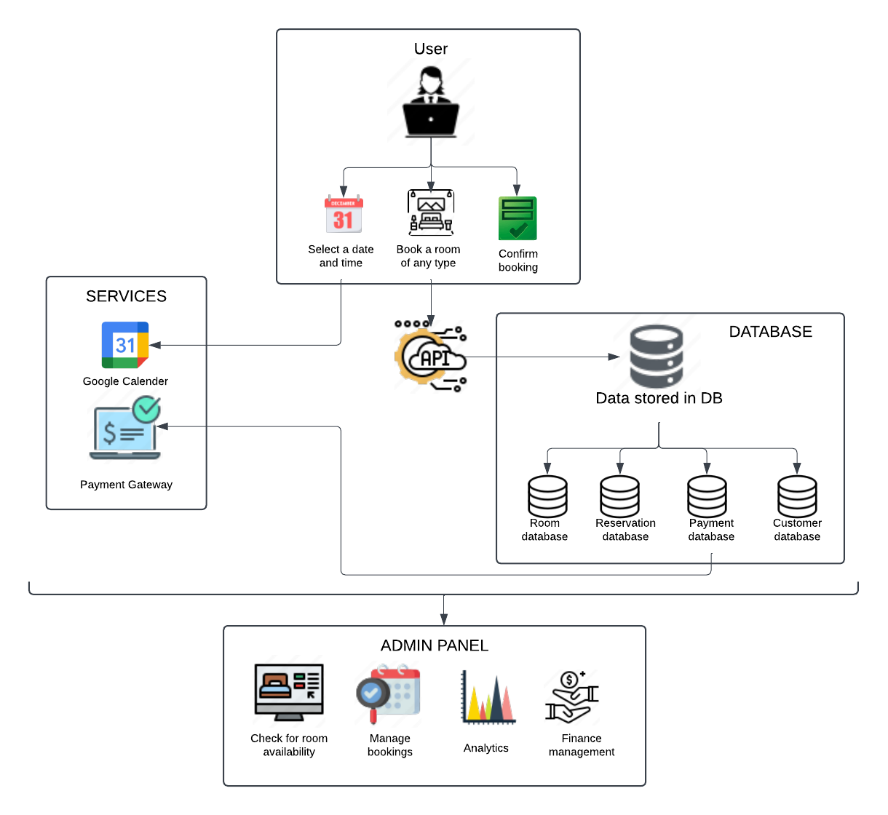

**3.4 DATA DICTIONARY**

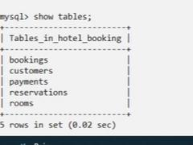

**1. TABLE: ROOMS**

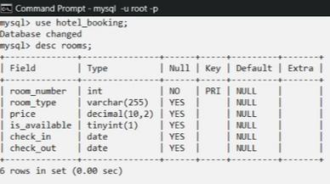

**PURPOSE:**   
The rooms table is designed to manage room-related data in systems like hotels or rental properties. It organizes essential details about rooms, including their identification, type, price, availability status, and booking dates. This structure supports core functions such as tracking room occupancy, managing reservations, and handling pricing for operations.

**2. TABLE 2: RESERVATIONS**

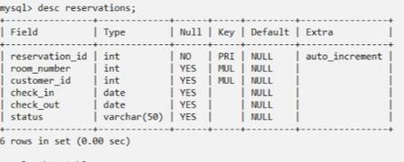

**PURPOSE:**

The purpose of the reservations table is to store and manage information related to room reservations in a system, such as for a hotel or similar business. It keeps details like reservation IDs, room numbers, customer information, and reservation dates.

It allows the system to track who reserved which room, when they are checking in and out, and the status of the reservation. This table is a critical part of managing hotel bookings or room scheduling systems.

**3. TABLE 3: PAYMENTS**

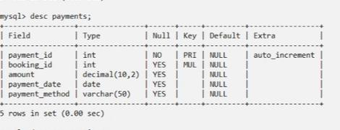

**PURPOSE:**

The payments table serves to record and manage payment details within a booking or reservation system. It includes a unique payment_id for each transaction, links to a specific booking through booking_id, and tracks the amount paid, the payment_date, and the payment_method used. This structure ensures efficient tracking of financial transactions, provides a clear association between payments and bookings, and supports auditing, reporting, and reconciliation of payment data within the system.

**4. TABLE 4: CUSTOMERS**

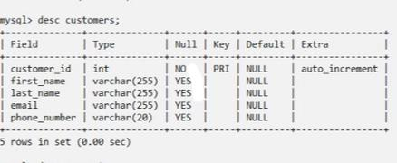

**PURPOSE:**

The customer’s table is designed to store and manage customer information systematically. It includes fields for customer identification (customer_id), personal details (first_name, last_name), and contact information (email, phone_number).

Each customer is uniquely identified by the customer_id, which is auto incremented. This structure allows businesses or systems to efficiently store, retrieve, and use customer data for various purposes, such as communication, transactions, and analytics. The table serves as a core component in applications like customer management systems, e-commerce platforms, or CRM tools.

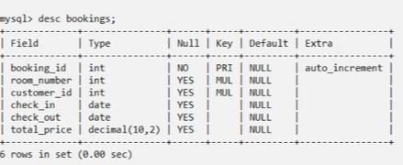**5. TABLE 5: BOOKINGS**

**PURPOSE:**

The bookings table is central to managing reservations in a system. It maintains a unique booking_id for each booking and associates it with specific room_number and customer_id. The table tracks the check_in and check_out dates to monitor reservation periods and availability of rooms. Additionally, it calculates the total_price for the stay, enabling accurate billing. This structured data supports efficient reservation handling, customer management, room allocation, and financial tracking for the system.

**3.5 ER DIAGRAM**

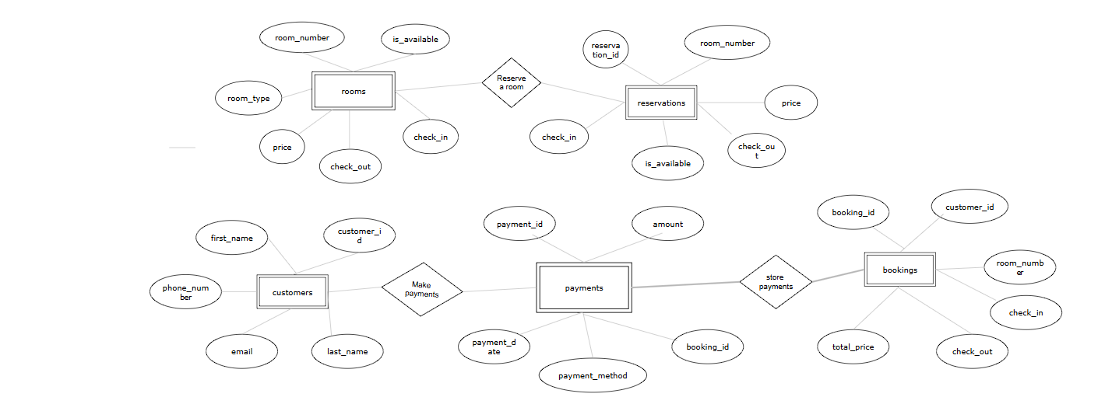

**IV. PROGRAM CODE**

**FRONTEND DESCRIPTION**

The front-end of the Hotel Reservation System is designed to provide an intuitive and visually appealing interface, allowing users to view, select, and book rooms seamlessly. Developed using HTML, CSS, and JavaScript, the layout is responsive and adapts to both desktop and mobile screens.

The homepage features a large hero image at the top that introduces the hotel’s ambiance, spanning the page's width to give a first impression of luxury and quality. A fixed navigation menu allows users to browse sections (Home, Rooms, Booking, About, Contact) quickly, while a welcome message or tagline just below the hero image entices visitors with descriptions of the hotel’s unique experiences.

The homepage also includes an interactive image gallery (slideshow) that highlights the hotel’s best views and settings. This dynamic feature, powered by JavaScript, allows users to navigate through various images of the hotel using next and previous arrows, enhancing the visual experience. The slideshow automatically transitions every 3 seconds, ensuring that visitors are engaged with the hotel's imagery as they explore the website.

In the Rooms section, users can explore each room type, including Suite, Sea-Facing, Chalet, Presidential, and Deluxe. Each room category is presented with a descriptive title, representative image, and key details like layout, bed size, amenities, and unique features. Notably, the Sea-Facing, Chalet, and Deluxe rooms specify that they offer queen-size beds only. Each room type’s nightly rate is clearly displayed, with Suite priced at ₹32,000, Sea-Facing at ₹15,000, Chalet at ₹10,000, Presidential at ₹55,000, and Deluxe at ₹23,000.

The Booking section features a calendar for selecting check-in and check-out dates, a dropdown for room selection that dynamically shows prices using JavaScript, and a field to enter the number of guests, ensuring room capacity compatibility. The dynamic price update is driven by JavaScript, allowing users to instantly see the price for their selected room type. A "Book Now" button submits the user’s selections for the reservation process, leading to a confirmation page.

JavaScript is also used for form validation to ensure proper selection of dates, as well as dynamic features like updating the price based on room selection and validating the check-out date to ensure it is later than the check-in date. Additionally, the system provides confirmation upon booking.

The About section provides a brief description of the hotel’s history, values, and distinctive features, along with an amenities list that highlights offerings like free Wi-Fi, pool access, complimentary breakfast, and 24-hour customer support. Lastly, the Contact section includes a form for users to enter their name, email, subject, and message to send inquiries, along with the hotel’s address, phone number, and email for direct communication.

This front-end design, powered by a combination of rich visuals, clear navigation, and responsive layouts, along with dynamic JavaScript functionalities, creates a smooth, engaging, and interactive booking experience that brings the hotel’s offerings to life for potential guests.

**FRONTEND (HTML)**

<!DOCTYPE html>

<html lang="en">

<head>

  <meta charset="UTF-8">

  <meta name="viewport" content="width=device-width, initial-scale=1.0">

  <title>Le Comfort</title>

  <link rel="stylesheet" href="styles.css">

</head>

<body>

  <header>

    <h1>Le Comfort</h1>

    <nav>

      <a href="#home">Home</a>

      <a href="#rooms">Rooms</a>

      <a href="#book">Book Now</a>

      <a href="#contact">Contact</a>

    </nav>

  </header>

  <section id="home" class="hero">

    <img src="images/homepage.jpg" alt="Hotel overview" class="hero-image">

    <h1>Welcome to Le Comfort</h1>

    <p>Your comfort is our priority</p>

    <a href="#book" class="button">Book Now</a>

  </section>

  <section class="gallery-section">

    <h2 class="gallery-title">OUR GALLERY</h2>

    <div class="slideshow">

      <div class="slide active">

          <img src="images/slide2.jpg" alt="Chill" class="slide-image">

          <div class="caption">A relaxing spot with a pleasant view</div>

      </div>

      <div class="slide">

          <img src="images/slide1.jpg" alt="Chill" class="slide-image">

          <div class="caption">A dream pool to rest by</div>

      </div>

      <div class="slide">

          <img src="images/slide3.jpg" alt="the sight" class="slide-image">

          <div class="caption">A bliss</div>

      </div>

      <!-- Navigation buttons -->

      <button class="prev">&#10094;</button>

      <button class="next">&#10095;</button>

  </div>

</section>

  <section id="rooms" class="rooms">

    <h2>OUR ROOMS</h2>

    <div class="room">

      <img src="images/suite.jpg" alt="Suite Room" class="room-image">

      <h4>Suite</h4>

      <p>Spacious suite with elegant decor.</p>

      <p>Layout: Twin beds</p>

      <p>₹32,000/night</p>

    </div>

    <div class="room">

      <img src="images/sea facing.jpg" alt="Sea Facing Room" class="room-image">

      <h4>Sea Facing</h4>

      <p>Enjoy breathtaking sea views.</p>

      <p>Layout: Queen size bed</p>

      <p>₹15,000/night</p>

    </div>

    <div class="room">

        <img src="images/chalet.jpg" alt="Chalet Room" class="room-image">

      <h4>Chalet</h4>

      <p>Cozy chalet for a serene experience.</p>

      <p>Layout: Twin beds</p>

      <p>₹10,000/night</p>

    </div>

    <div class="room">

      <img src="images/presidential suite.jpg" alt="Presidential Room" class="room-image">

      <h4>Presidential</h4>

      <p>Luxury at its finest, for a memorable stay.</p>

      <p>Layout: Twin beds</p>

      <p>₹55,000/night</p>

    </div>

    <div class="room">

      <img src="images/deluxe rooms.jpg" alt="Deluxe Room" class="room-image">

      <h4>Deluxe</h4>

      <p>Comfortable deluxe room with premium amenities.</p>

      <p>Layout: Queen size bed</p>

      <p>₹23,000/night</p>

    </div>

  </section>

  <section id="book" class="booking-form">

    <h3>Book Your Stay</h3>

    <form id="booking-form">

        <label for="name">Name:</label>

        <input type="text" id="name" name="name" required>

        <label for="email">Email:</label>

        <input type="email" id="email" name="email" required>

        <label for="checkin">Check-In Date:</label>

        <input type="date" id="checkin" name="checkin" required>

        <label for="checkout">Check-Out Date:</label>

        <input type="date" id="checkout" name="checkout" required>

        <label for="room">Room Type:</label>

        <select id="room" name="room">

            <option value="suite">Suite</option>

            <option value="sea-facing">Sea Facing</option>

            <option value="chalet">Chalet</option>

            <option value="presidential">Presidential</option>

            <option value="deluxe">Deluxe</option>

        </select>

        <!-- Display price for the selected room -->

        <p>Price: <span id="price">₹15000</span>/night</p>

        <button type="submit" class="button">Reserve Now</button>

    </form>

</section>

  <footer>

    <p>&copy; 2024 Le Comfort. All rights reserved.</p>

  </footer>

  <!-- Link to JavaScript file -->

  <script src="script.js"></script>

</body>

</html>

**FRONTEND (CSS)**

/* Base Styles */

* {

  margin: 0;

  padding: 0;

  box-sizing: border-box;

}

body {

  font-family: Arial, sans-serif;

  line-height: 1.6;

  color: #fff; /* White text color for better contrast with dark background */

  background-image: url('images/background.jpg'); /* Background image */

  background-size: cover;

  background-position: center;

  background-repeat: no-repeat;

  background-attachment: fixed;

}

/* Header */

header {

  background-color: #333;

  color: #fff;

  padding: 1rem;

  text-align: center;

}

header nav a {

  color: #fff;

  margin: 0 1rem;

  text-decoration: none;

}

/* Hero Section */

.hero {

  position: relative;

  text-align: center;

  padding: 2rem 0;

  background-color: rgba(0, 0, 0, 0.6); /* Semi-transparent black overlay */

}

.hero h2 {

  font-size: 3rem;

  margin-bottom: 0.5rem;

  color: #fff; /* White text for contrast */

}

.hero p {

  font-size: 1.1rem;

  color: #ccc; /* Light grey text color for readability */

}

.hero-image {

  width: 100%;

  height: auto;

  max-height: 500px;

  object-fit: cover;

  display: block;

  margin: 0 auto 1rem;

}

/* Button */

.button {

  display: inline-block;

  padding: 0.7rem 1.5rem;

  background-color: #f5b8b8; /* Visible color */

  color: #fff;

  text-decoration: none;

  border-radius: 5px;

  margin-top: 1rem;

  cursor: pointer;

}

.button:hover {

  background-color: #f5b8b8; /* Darker blue on hover */

}

section .button {

  background-color: #f5b8b8; /* Visible color */

  color: #fff;

}

/* Rooms and Booking Form Sections */

.rooms, .booking-form {

  padding: 2rem;

  text-align: center;

}

.rooms .room {

  background-color: rgba(255, 255, 255, 0.8); /* Light background with transparency */

  padding: 1rem;

  margin: 1rem auto;

  width: 80%;

  max-width: 300px;

  border-radius: 5px;

  color: #333; /* Dark text for readability */

}

.room-image {

  width: 100%;

  height: auto;

  max-height: 500px;

  object-fit: cover;

  border-radius: 5px;

  margin-bottom: 0.5rem;

}

.booking-form form {

  display: flex;

  flex-direction: column;

  max-width: 400px;

  margin: 0 auto;

}

.booking-form label {

  margin-top: 1rem;

  color: rgb(255, 234, 194); /* Change to white for better visibility */

  font-weight: bold; /* Optional: makes the labels stand out more */

}

.booking-form input, .booking-form select {

  padding: 0.5rem;

  margin-top: 0.5rem;

}

/* Footer */

footer {

  background-color: #333;

  color: #fff;

  text-align: center;

  padding: 1rem;

}

/* Optional welcome-section styling */

.welcome-section {

  color: #ccc; /* Light grey for readability */

  text-align: center;

}

/* Slideshow container */

.slideshow {

  display: flex;

  justify-content: center;

  align-items: center;

  overflow: hidden;

  position: relative;

  max-width: 800px; /* Set max width for slideshow container */

  margin: 0 auto; /* Center the slideshow container */

}

.slide {

  display: none;

  text-align: center;

}

.slide.active {

  display: block;

}

.slide-image {

  width: 100%; /* Make the image responsive to container width */

  height: auto; /* Keep aspect ratio */

  max-height: 500px; /* Set a max height for the image */

  object-fit: cover; /* Crop the image if it doesn’t fit the container */

  display: block;

}

.caption {

  position: absolute;

  bottom: 20px; /* Adjust the position from the bottom */

  left: 50%;

  transform: translateX(-50%);

  color: white;

  background-color: rgba(0, 0, 0, 0.6); /* Semi-transparent background */

  padding: 10px 20px;

  border-radius: 5px;

  font-size: 1em;

  text-align: center;

}

.prev, .next {

  cursor: pointer;

  position: absolute;

  top: 50%;

  transform: translateY(-50%);

  padding: 10px;

  color: white;

  font-weight: bold;

  font-size: 24px;

  background: rgba(0, 0, 0, 0.5);

  border: none;

  border-radius: 50%;

}

.prev {

  left: 10px;

}

.next {

  right: 10px;

}

.gallery-section {

  text-align: center;

  margin-bottom: 20px;

}

.gallery-title {

  font-size: 24px; /* Adjust font size as needed */

  font-weight: bold;

  color: white; /* Change color as needed */

  margin-bottom: 10px; /* Space between title and slideshow */

}

**FRONTEND (JAVASCRIPT)**

class Slider {

slideIndex = 0;

slides = [];

constructor() {

this.slides = document.querySelectorAll(".slide");

document

.querySelector(".next")

.addEventListener("click", () => this.nextSlide());

document

.querySelector(".prev")

.addEventListener("click", () => this.prevSlide());

}

nextSlide() {

this.slideIndex = (this.slideIndex + 1) % this.slides.length;

this.showSlide();

}

prevSlide() {

this.slideIndex =

(this.slideIndex - 1 + this.slides.length) % this.slides.length;

this.showSlide();

}

showSlide() {

this.slides.forEach((slide, i) => {

slide.classList.remove("active"); // Hide all slides

if (i === this.slideIndex) {

slide.classList.add("active"); // Show the current slide

}

});

}

rotateSlides() {

// Automatic slideshow every 3 seconds

setInterval(() => {

this.nextSlide();

}, 3000);

}

}

class App {

BASE_URL = "http://127.0.0.1:5000/api";

getRooms() {

const roomDropdown = document.getElementById("room_type");

// Call the API to fetch room data

fetch(this.BASE_URL + "/rooms")

.then((response) => {

if (!response.ok) {

throw new Error(`API call failed with status ${response.status}`);

}

return response.json();

})

.then((rooms) => {

rooms = rooms?.available_rooms;

// Clear existing options

roomDropdown.innerHTML = "";

// Add a default option

const defaultOption = document.createElement("option");

defaultOption.value = "";

defaultOption.textContent = "Select a room";

roomDropdown.appendChild(defaultOption);

// Populate dropdown with room data

for (const [roomType, price] of Object.entries(rooms)) {

const option = document.createElement("option");

option.value = roomType;

option.dataset.price = price;

option.textContent = `${

roomType.charAt(0).toUpperCase() + roomType.slice(1)

} - ₹${price}/night`;

roomDropdown.appendChild(option);

}

})

.catch((error) => {

console.error("Error fetching rooms:", error);

roomDropdown.innerHTML = `<option value="">Failed to load rooms</option>`;

});

}

init() {

this.getRooms();

const checkInInput = document.getElementById("checkin");

const checkOutInput = document.getElementById("checkout");

checkInInput.addEventListener("change", () => {

checkOutInput.min = checkInInput.value; // Sets minimum check-out date to the selected check-in date

});

// Slide show controller

const slideController = new Slider();

slideController.showSlide();

slideController.rotateSlides();

// Select the room dropdown and price display element

const roomTypeSelect = document.getElementById("room_type");

const priceDisplay = document.getElementById("price");

// Update the price when the user selects a room type

roomTypeSelect.addEventListener("change", (ev) => {

const roomPrice =

ev.target.options[ev.target.selectedIndex].dataset.price;

priceDisplay.textContent = `₹${roomPrice}/night`; // Update price text

});

// Booking confirmation example

document

.getElementById("booking-form")

.addEventListener("submit", async (event) => {

event.preventDefault();

// Get form values

const name = document.getElementById("name").value;

const email = document.getElementById("email").value;

const roomType = document.getElementById("room_type").value;

const checkinDate = document.getElementById("checkin").value;

const checkoutDate = document.getElementById("checkout").value;

// Construct the payload

const bookingData = {

name,

email,

room_type: roomType,

checkin_date: checkinDate,

checkout_date: checkoutDate,

};

console.log("Booking Data:", bookingData);

try {

// Send data to API

const response = await fetch(this.BASE_URL + "/book", {

method: "POST",

headers: {

"Content-Type": "application/json",

},

body: JSON.stringify(bookingData),

});

if (response.ok) {

alert(

"Thank you for booking with us! We'll confirm your reservation shortly."

);

} else {

const error = await response.json();

alert("Error: " + error.error);

}

} catch (error) {

console.error("Error:", error);

alert("Failed to send booking. Please try again later.");

}

});

// Simple scroll animation

window.addEventListener("scroll", () => {

const roomsSection = document.querySelector("#rooms");

if (window.scrollY > roomsSection.offsetTop - window.innerHeight / 2) {

roomsSection.classList.add("fade-in");

}

});

}

}

window.addEventListener("load", function () {

const app = new App();

app.init();

});

**SCRIPT.JS**

// Smooth Scroll for Navigation Links

document.querySelectorAll('header nav a').forEach(anchor => {

    anchor.addEventListener('click', function (e) {

      e.preventDefault();

      const targetId = this.getAttribute('href').substring(1);

      const targetElement = document.getElementById(targetId);

      window.scrollTo({

        top: targetElement.offsetTop - 80, // Adjusting for header height

        behavior: 'smooth'

      });

    });

  });

  // Simple Form Validation

  const bookingForm = document.querySelector('.booking-form form');

  bookingForm.addEventListener('submit', function (e) {

    e.preventDefault();  // Prevent form submission

    const name = document.getElementById('name').value;

    const email = document.getElementById('email').value;

    const checkin = document.getElementById('checkin').value;

    const checkout = document.getElementById('checkout').value;

    // Basic validation

    if (!name || !email || !checkin || !checkout) {

      alert("Please fill out all fields.");

      return;

    }

    if (new Date(checkin) >= new Date(checkout)) {

      alert("Check-out date must be after check-in date.");

      return;

    }

    // If validation passes

    alert("Your booking has been submitted!");

    bookingForm.reset();  // Reset the form

  });

**APP.PY**

from flask import Flask, request, jsonify

from flask_sqlalchemy import SQLAlchemy

from datetime import datetime

from flask_cors import CORS

app = Flask(__name__)

CORS(app)

# Configure SQLite database

app.config['SQLALCHEMY_DATABASE_URI'] = 'sqlite:///hotel_bookings.db'

app.config['SQLALCHEMY_TRACK_MODIFICATIONS'] = False

db = SQLAlchemy(app)

# Define Models

class Booking(db.Model):

__tablename__ = 'bookings'

id = db.Column(db.Integer, primary_key=True)

name = db.Column(db.String(100), nullable=False)

email = db.Column(db.String(100), nullable=False)

room_type = db.Column(db.String(50), nullable=False)

checkin_date = db.Column(db.Date, nullable=False)

checkout_date = db.Column(db.Date, nullable=False)

stay_duration = db.Column(db.Integer, nullable=False)

total_price = db.Column(db.Float, nullable=False)

def to_dict(self):

"""Convert model instance to dictionary."""

return {

"id": self.id,

"name": self.name,

"email": self.email,

"room_type": self.room_type,

"checkin_date": self.checkin_date.strftime("%Y-%m-%d"),

"checkout_date": self.checkout_date.strftime("%Y-%m-%d"),

"stay_duration": self.stay_duration,

"total_price": self.total_price

}

# Initialize the database

@app.before_request

def create_tables():

db.create_all()

# Room Prices

room_prices = {

'suite': 32000,

'sea-facing': 15000,

'chalet': 10000,

'presidential': 55000,

'deluxe': 23000

}

# API Endpoints

@app.route('/api/rooms', methods=['GET'])

def get_rooms():

"""Get a list of available room types with prices."""

return jsonify({"available_rooms": room_prices})

@app.route('/api/book', methods=['POST'])

def book_room():

"""Book a room."""

data = request.json

try:

# Get user details

name = data.get("name")

email = data.get("email")

room_type = data.get("room_type").lower()

checkin_date = datetime.strptime(data.get("checkin_date"), "%Y-%m-%d")

checkout_date = datetime.strptime(data.get("checkout_date"), "%Y-%m-%d")

# Validate inputs

if room_type not in room_prices:

return jsonify({"error": "Invalid room type. Please select a valid room type."}), 400

if checkin_date >= checkout_date:

return jsonify({"error": "Check-out date must be after check-in date."}), 400

# Calculate stay duration

stay_duration = (checkout_date - checkin_date).days

if stay_duration <= 0:

return jsonify({"error": "Stay duration must be at least 1 day."}), 400

# Calculate total price

price_per_night = room_prices[room_type]

total_price = price_per_night * stay_duration

# Save booking to the database

booking = Booking(

name=name,

email=email,

room_type=room_type.capitalize(),

checkin_date=checkin_date,

checkout_date=checkout_date,

stay_duration=stay_duration,

total_price=total_price

)

db.session.add(booking)

db.session.commit()

# Create booking summary

return jsonify({

"message": "Booking successful!",

"booking_summary": booking.to_dict()

}), 200

except ValueError as e:

return jsonify({"error": str(e)}), 400

except Exception as e:

return jsonify({"error": "An error occurred during booking.", "details": str(e)}), 500

@app.route('/api/bookings', methods=['GET'])

def get_bookings():

"""Get all bookings from the database."""

try:

bookings = Booking.query.all()

return jsonify({"bookings": [booking.to_dict() for booking in bookings]}), 200

except Exception as e:

return jsonify({"error": "Could not fetch bookings.", "details": str(e)}), 500

if __name__ == '__main__':

app.run(debug=True)

**BACKEND (PYTHON)**

import mysql.connector

from mysql.connector import Error

class HotelBookingSystem:

def __init__(self, host, user, password, database):

try:

self.connection = mysql.connector.connect(

host=host,

user=user,

password=password,

database=database

)

if self.connection.is_connected():

print("Successfully connected to the database")

except Error as e:

print("Error while connecting to MySQL", e)

def add_customer(self, customer_name, email, phone):

"""Adds a new customer to the customers table."""

try:

cursor = self.connection.cursor()

query = "INSERT INTO customers (name, email, phone) VALUES (%s, %s, %s)"

cursor.execute(query, (customer_name, email, phone))

self.connection.commit()

print("Customer added successfully.")

except Error as e:

print("Error adding customer:", e)

def make_reservation(self, customer_id, room_id, check_in, check_out):

"""Creates a reservation and adds it to the reservations table."""

try:

cursor = self.connection.cursor()

query = "INSERT INTO reservations (customer_id, room_id, check_in, check_out) VALUES (%s, %s, %s, %s)"

cursor.execute(query, (customer_id, room_id, check_in, check_out))

self.connection.commit()

print("Reservation created successfully.")

except Error as e:

print("Error creating reservation:", e)

def record_payment(self, reservation_id, amount, payment_date):

"""Records a payment for a reservation."""

try:

cursor = self.connection.cursor()

query = "INSERT INTO payments (reservation_id, amount, payment_date) VALUES (%s, %s, %s)"

cursor.execute(query, (reservation_id, amount, payment_date))

self.connection.commit()

print("Payment recorded successfully.")

except Error as e:

print("Error recording payment:", e)

def view_all_rooms(self):

"""Fetches and displays all available rooms from the rooms table."""

try:

cursor = self.connection.cursor()

query = "SELECT * FROM rooms"

cursor.execute(query)

rooms = cursor.fetchall()

for room in rooms:

print(room)

except Error as e:

print("Error fetching rooms:", e)

def view_bookings(self):

"""Displays all bookings from the bookings table."""

try:

cursor = self.connection.cursor()

query = "SELECT * FROM bookings"

cursor.execute(query)

bookings = cursor.fetchall()

for booking in bookings:

print(booking)

except Error as e:

print("Error fetching bookings:", e)

def close_connection(self):

"""Closes the connection to the MySQL database."""

if self.connection.is_connected():

self.connection.close()

print("Database connection closed.")

# Example usage

def main():

# Update with your own database credentials

system = HotelBookingSystem(host="localhost", user="root", password="Janet_88", database="hotel_booking")

# Sample operations

print("\nAll Rooms:")

system.view_all_rooms()

print("\nAll Bookings:")

system.view_bookings()

system.close_connection()

if __name__ == "__main__":

main()

**V. RESULT AND DISCUSSION**

**5.1 RESULT**

The hotel reservation system successfully meets the core requirements outlined in the project. The application provides an intuitive interface for users to book rooms, check availability, and securely process payments. The system’s dynamic features, such as real-time pricing updates and seamless navigation, enhance the overall user experience. The backend, supported by a relational database, efficiently manages room types, bookings, and user data. Admin functionalities are robust, with tools for managing bookings, generating reports, and ensuring smooth operations. Overall, the system demonstrates reliable performance and user satisfaction, fulfilling the project's objectives.

**5.2 TESTING**

Testing a hotel reservation system requires a comprehensive approach to ensure smooth operation across all functionalities, from booking to payments. Starting with Booking Functionality, testers should verify that single and multiple room bookings work correctly and that the system can handle unavailable dates with appropriate error messages. The system should also update room availability in real time. Cancellation and Modifications are essential to test, particularly within and beyond the cancellation period, to ensure that the system applies any penalties accurately and allows for smooth modifications in booking details.

Payment Processing involves verifying successful transactions across different payment methods (e.g., credit cards, PayPal) and confirming secure handling of sensitive information, such as compliance with PCI standards. In User Interface (UI) Testing it is crucial to ensure that booking forms and navigation work well across devices and browsers, with clear labelling for room types, amenities, and prices to facilitate an intuitive user experience.

For Search and Filtering Options, testers should validate that users can filter search results by dates, room types, amenities, or price range and receive accurate, relevant results. User Authentication and Profiles testing includes checking that user details are saved correctly upon registration, that booking history is accessible, and that features like "Forgot Password" function securely.

Notifications and Emails testing is essential for ensuring timely updates are sent to users, including reservation confirmations, payment receipts, reminders, and cancellation notices. System Performance and Security testing, which includes load testing under high user volume and validation of data encryption for secure access control, is also a key area.

Lastly, Reporting and Analytics must be tested to ensure that the system generates accurate occupancy, revenue reports, and behavioral analytics for admins. Covering these areas thoroughly ensures that the hotel reservation system remains reliable, secure, and user-friendly, providing a seamless experience for both customers and administrators.

**5.3 FUTURE SCOPE OF THE PROJECT**

The future scope of a hotel reservation system project offers a wide range of enhancements that can improve user experience, streamline operations, and ensure long-term competitiveness. The evolving needs of customers, coupled with advancements in technology, present an exciting landscape for expanding the functionality and efficiency of such systems.

One significant area of growth is Advanced Personalization and Artificial Intelligence (AI) Integration. By incorporating AI, the system can offer personalized recommendations tailored to the preferences, booking history, and travel patterns of individual users. Machine learning algorithms can analyze data to suggest room upgrades, special amenities, or exclusive packages, helping create a unique, customized experience. For instance, if a user frequently books a room with a city view, the system could prioritize similar room types in their search results. Furthermore, AI can assist with dynamic pricing based on demand, time of year, or customer loyalty, ensuring competitive rates and optimized occupancy.

Another future scope is the Development of a Mobile App and Enhanced Cross-Platform Compatibility. In today’s mobile-first world, travelers increasingly rely on their smartphones for planning and booking their trips. A dedicated mobile app would enable users to book rooms, check in, receive notifications, and manage their reservations conveniently from their mobile devices. Features like push notifications can enhance customer engagement by sending reminders, promotional offers, or last-minute deals. Optimizing the system for mobile browsers and ensuring seamless integration across devices like tablets and desktops can further boost accessibility, allowing customers to interact with the system whenever and wherever they need.

Integration with Other Travel and Hospitality Services is another area with vast potential. By partnering with airlines, car rental companies, tour operators, and other hospitality services, the system can offer a one-stop solution for users. This integrated travel solution would allow users to book flights, hotels, transportation, and even local tours or experiences all in one place. For example, a customer booking a hotel could also receive bundled offers for nearby tourist attractions or restaurant reservations, creating a full travel package that enhances convenience and satisfaction. Cross-promotional partnerships with other service providers can lead to increased revenue opportunities, as well as a more cohesive experience for the end-user.

To further enhance user support, Automated Customer Assistance Using Chatbots can be implemented. Chatbots equipped with natural language processing (NLP) capabilities would provide real-time assistance for common customer inquiries, such as booking modifications, cancellations, or room availability. Available 24/7, these chatbots can handle multiple user queries simultaneously, reducing dependency on human customer support and providing quick, consistent responses. By responding to frequently asked questions and guiding users through the booking process, chatbots can streamline customer interactions, leaving more complex issues for human agents to handle.

Enhanced Data Analytics and Reporting capabilities would also add tremendous value to the hotel reservation system. Advanced analytics could track booking trends, customer preferences, occupancy rates, and revenue metrics. This data can be leveraged to make data-driven decisions, allowing hotels to anticipate demand, adjust pricing strategies, and optimize their marketing efforts. By identifying peak periods, high-demand room types, and preferred amenities, hotel management can tailor services to better meet customer needs, ultimately leading to improved satisfaction and loyalty. Analytics can also support predictive modeling, helping hotels anticipate future booking patterns and adjust their operational strategies accordingly.

Sustainability and Eco-Friendly Initiatives can also be integrated into the reservation system to attract environmentally conscious travelers. Features such as showing carbon footprint data for hotel stays, suggesting eco-friendly amenities, or providing options for donations to environmental causes can help align the hotel’s offerings with the values of modern travelers. Additionally, incorporating sustainability metrics into hotel ratings or reviews can provide guests with a clearer understanding of a property’s environmental impact, allowing them to make informed decisions.

Lastly, as Cybersecurity and Privacy Concerns continue to grow, ensuring that the reservation system adheres to the latest security standards is crucial. Future enhancements should prioritize encryption, two-factor authentication, and GDPR compliance to protect user data. As the system grows and integrates with additional services, maintaining strict data security protocols will help build customer trust and protect against potential breaches.

**5.4 FRONT-END LAYOUT**

**HOME PAGE:**

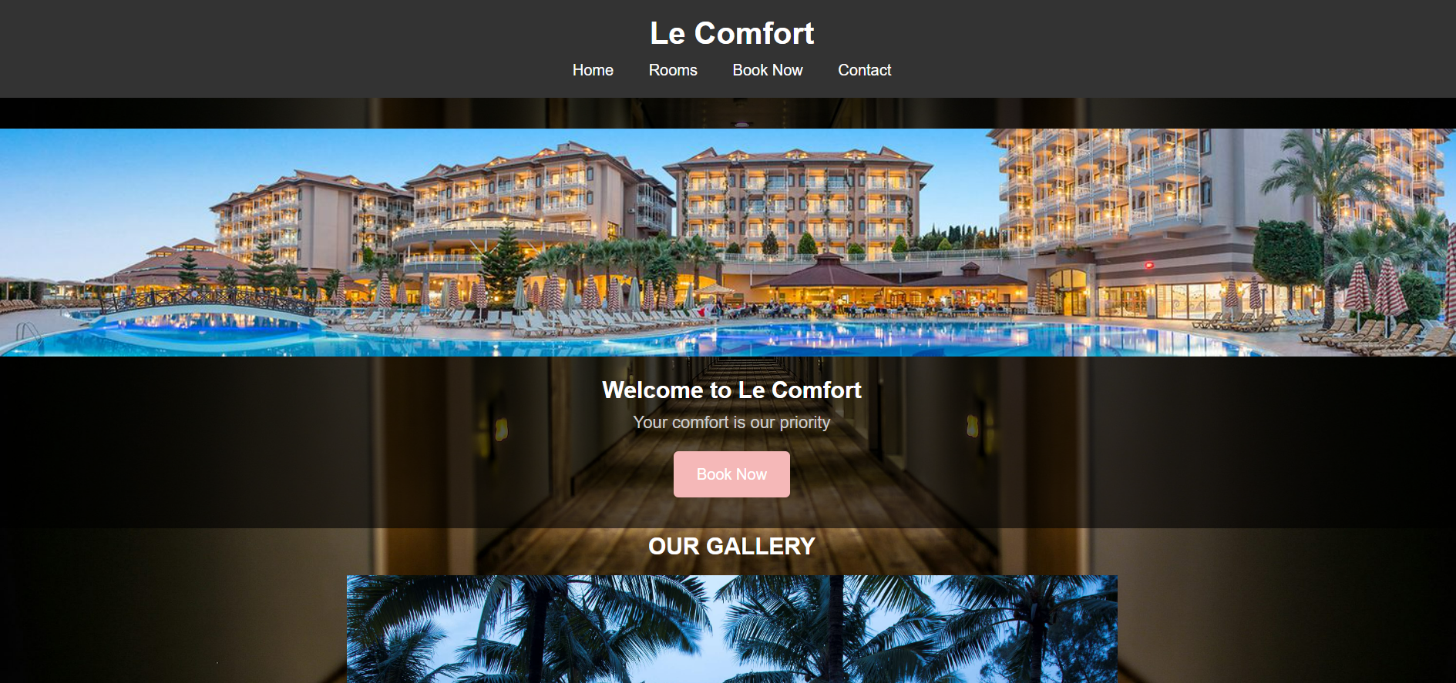

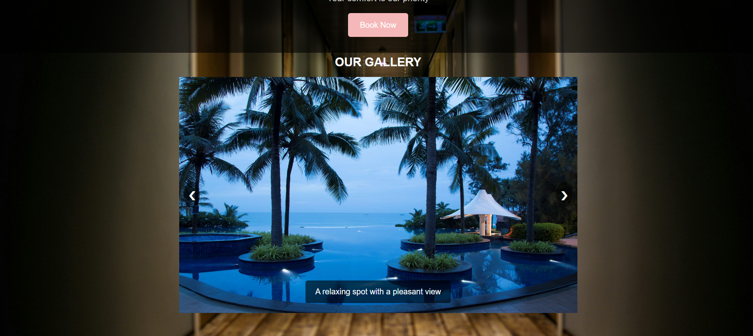

**ROOMS:**

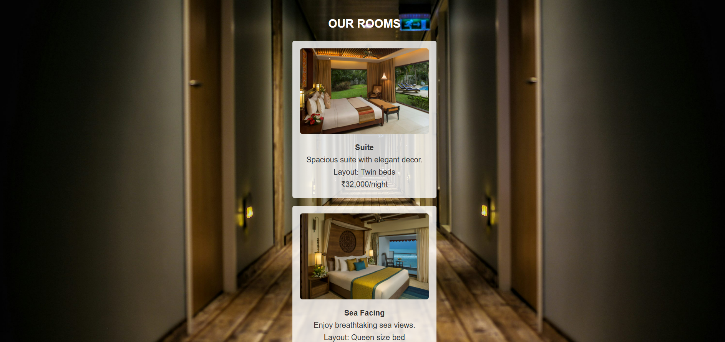

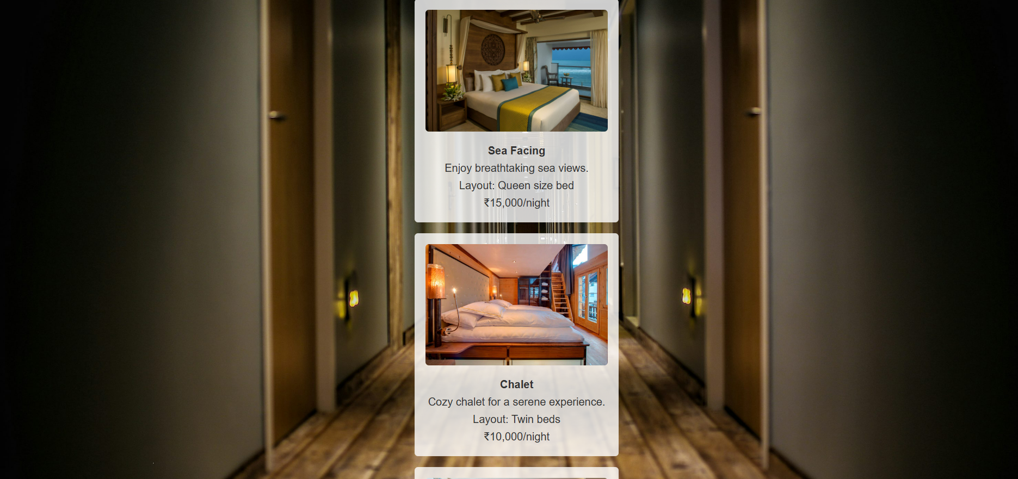

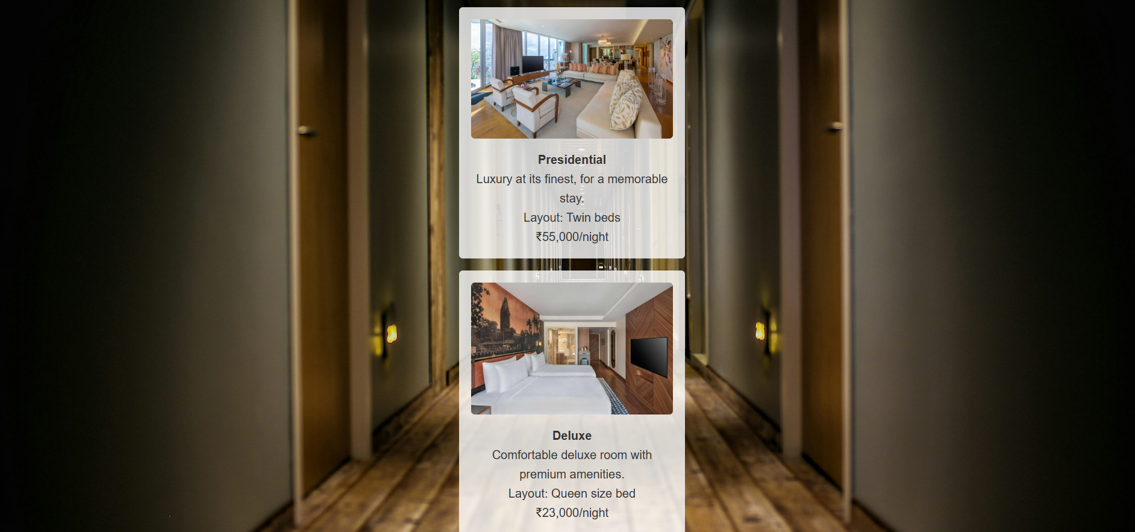

**BOOKING PAGE:**

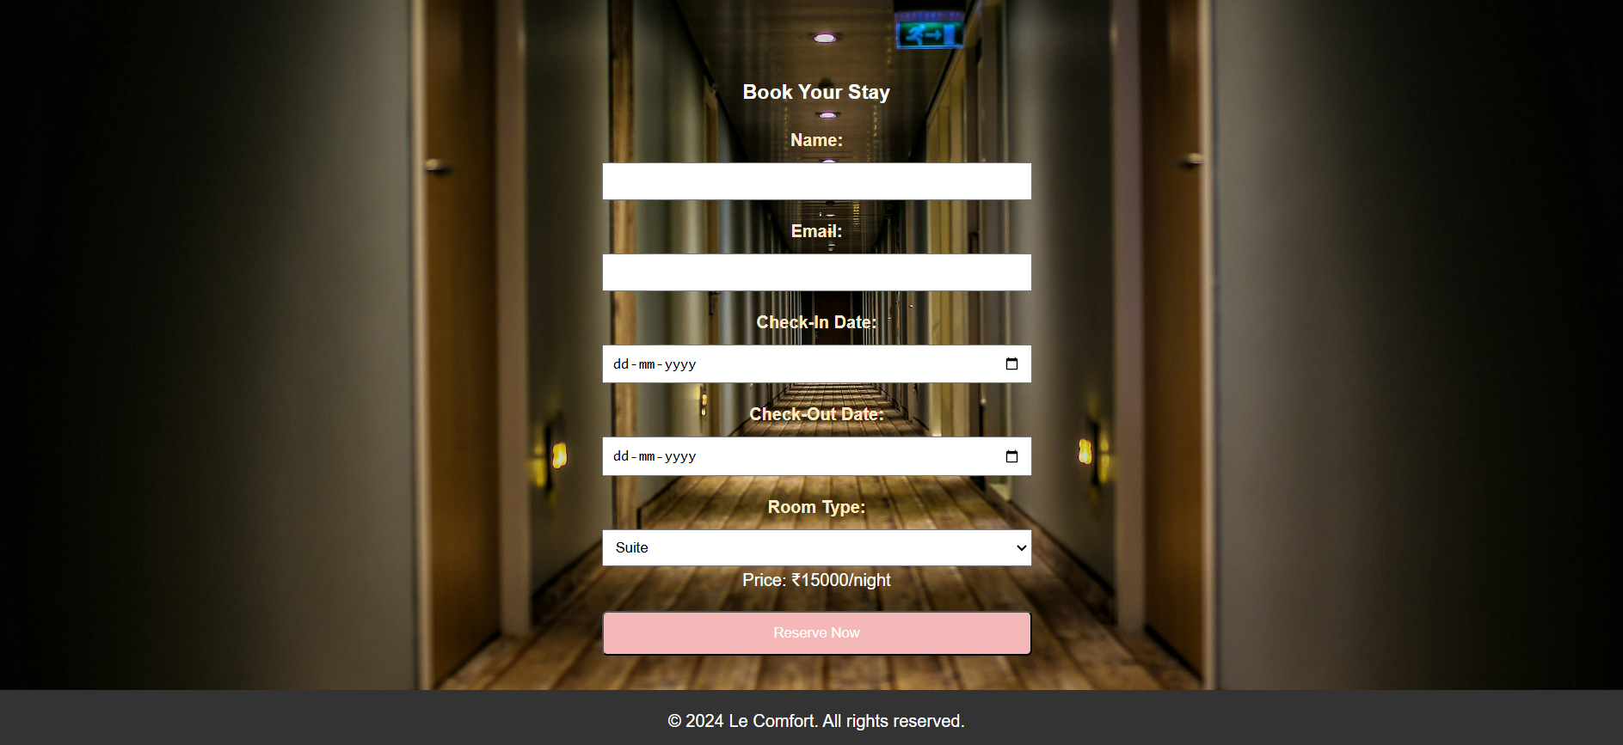

**VI. CONCLUSION**

In conclusion, the future of a hotel reservation system is poised for remarkable transformation, driven by the rapidly evolving demands of modern travellers and the advancements in technology. A system that incorporates personalized AI-driven recommendations can significantly enhance the guest experience, providing suggestions and offers tailored to individual preferences and booking history. This level of customization not only elevates user satisfaction but also builds loyalty, as customers are more likely to return to a platform that understands and anticipates their needs. Additionally, AI-powered dynamic pricing models can optimize room rates based on demand, helping hotels maintain competitive pricing and maximize occupancy.

The development of a dedicated mobile application and improved cross-platform compatibility offers another critical advantage, as travellers increasingly rely on mobile devices for quick and convenient access to services. A mobile app that supports seamless booking, push notifications, and integrated management of reservations ensures customers can interact with the system anytime, anywhere. This ease of access fosters greater engagement allows for real-time updates, and encourages customers to take advantage of timely deals and offers. By meeting customers on the platforms, they use most, hotels can strengthen their brand presence and expand their market reach.

Expanding integration with other travel and hospitality services creates an opportunity to develop a comprehensive travel solution, allowing users to book flights, accommodations, car rentals, and even local experiences in one place. This one-stop-shop approach not only simplifies the booking process for users but also generates new revenue streams through cross-promotional partnerships. By consolidating various aspects of the travel journey, the reservation system positions itself as a central hub for travel planning, appealing to customers seeking convenience and consistency in their travel arrangements.

Another essential enhancement is automated customer support using chatbots. With 24/7 availability, chatbots can provide instant responses to common inquiries, assist with cancellations, and guide users through the booking process, ensuring prompt support without the need for additional human resources. By handling routine queries efficiently, chatbots improve customer satisfaction while allowing customer service teams to focus on more complex issues. This automated support can play a vital role in streamlining operations and meeting customer expectations for quick, reliable assistance.

Data analytics and reporting offer a strategic advantage, as they enable hotels to make informed, data-driven decisions. By analyzing booking trends, customer preferences, and revenue metrics, hotels can better anticipate demand, adjust pricing, and design targeted marketing campaigns. Predictive analytics can further enhance this by forecasting future demand, helping hotels prepare for peak seasons, optimize resources, and fine-tune their services. This data-centric approach ensures that hotels are responsive to market changes, allowing them to meet guest needs more effectively.

Furthermore, as environmental awareness grows, integrating sustainability-focused features** can attract eco-conscious travelers. By providing data on carbon footprints, promoting eco-friendly amenities, and enabling guests to contribute to environmental causes, hotels can align themselves with the values of today’s travelers. This not only enhances brand image but also demonstrates a commitment to responsible tourism, a key differentiator in a competitive industry.

Finally, cybersecurity and privacy remain paramount as reservation systems expand and become more complex. Ensuring data protection through encryption, two-factor authentication, and GDPR compliance builds trust with customers and safeguards against data breaches. As the system grows and integrates with additional services, strict adherence to security protocols is essential to protect sensitive user information and maintain a trustworthy reputation.

In summary, the future of a hotel reservation system is ripe with possibilities that can revolutionize the travel experience. By embracing personalized AI, mobile accessibility, service integration, automated support, data-driven insights, sustainability, and robust cybersecurity, the system can transform into a highly efficient, user-centric platform. These advancements not only streamline operations for hotels but also offer customers a seamless, comprehensive, and enjoyable booking experience. Positioned as a market leader, such a system can adapt to emerging trends, exceed customer expectations, and pave the way for a new era in digital hospitality.

**VII. REFERENCES**

Norton, L. (2022). *How Mobile App Security Keeps Sensitive Information Safe*. Available at [norton.com](https://www.norton.com)

OWASP Foundation. (2023). *Best Practices for Secure Mobile Development*. Available at [owasp.org](https://www.owasp.org)

Hospitality Net. (2023). *Emerging Technology Trends in Hospitality*. Retrieved from [hospitalitynet.org](https://www.hospitalitynet.org)

Skift. (2023). *AI in Hospitality: Transforming Guest Experience and Operational Efficiency*. Available at [skift.com](https://www.skift.com)

Oracle Hospitality Blog. (2023). *Building the Future of Hotel Technology: Trends for 2023 and Beyond*. Available at [oracle.com](https://www.oracle.com/industries/hospitality/)